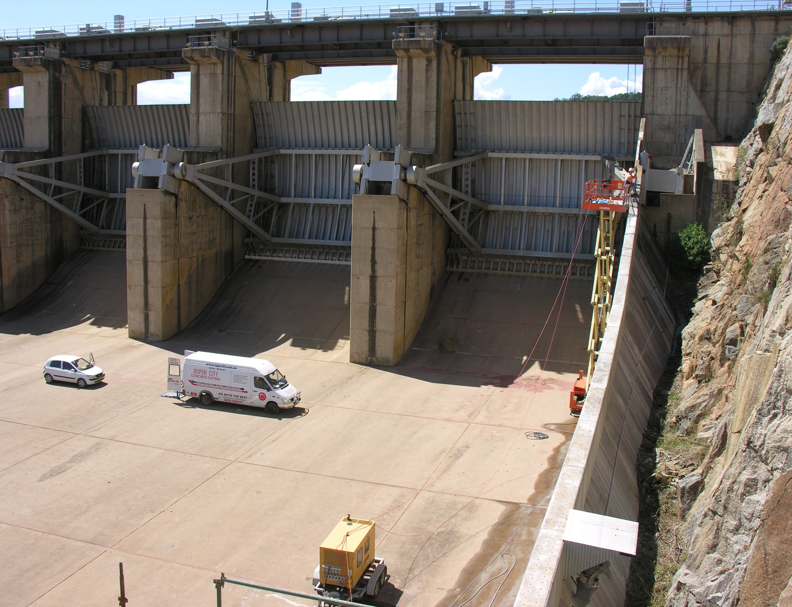
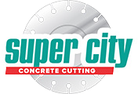
Wyangala Dam Cowra

Wyangala Dam Cowra

Reference for our work at Wyangala Dam from the REED Group:
"Jason Franken and his team from Super City Concrete Cutting were engaged in Reed Group's Wyangala Dam NSW Stage 1B Spillway Chute Wall Raising Project during March and April 2010. Super City's involvement was in fixed sump lump sum works primarily in core drilling large quantities of holes up to 60mm diameter to depths of up to 1000mm for placement of starter bars for the chute wall extensions either side of the Wyangal Dam Spillway.
The work was difficult in nature due to all works being at heights from 6m to 15m from the spillway slab, with the main access via boom lift or scissor lift.
Super City was easy to manage, with OHS and quality compliance excellent at all times. When issues were raised requiring Super City's attention, they acted promptly and with courtesy.
Some variations to the original work scope arose during the execution of the works, and discussions and determinations on quantities and values were open and honest.

In the administration of their contract with us, we encountered no difficulty or dispute, and issues were dealt with in good time.
Common applications are:
- steel water or fuel pipelines storage tanks
- steel pier piles
- ships and boats
- offshore oil platforms and onshore oil well casings
- and metal reinforcement bars in concrete buildings and structures.

Best results indicated that the overage underside cover was around 60mm from the existing reinforcing layers
Procedure:
Super City Concrete Cutting supplied a WX15 track saw and a custom built blade manu- factured by Tyrolit Australia to complete the works.
- A series of 10mm wide x 50mm deep slots were cut using the track saw system to provide access for the cathodic protection.
- 280 lineal meters of inverted sawing 10mm wide x 50mm deep was completed on the jetty so the cathodic protection could be installed.
- The start of the jetty structure from waters edge proved most challenging as the ac- cess area to the underside of the jetty was only 650mm high.

- Operators worked their way through setting up the track in very tight areas, suc- cessfully aligning the track so all specified tolerances were achieved.

Safety:
Due to the restricted work area safety blade guards that are normally fitted to the unit could not be fitted This safety issue was identified prior to work commencing and a safe work method statement was complied and present- ed to the client for approval.The ability to re- mote control the track saw from a safe working distance reinforced our capabilities to maintain a safe work environment for this section of the work.

Project Completion:
The inverted sawing took 4 days to complete, providing the client with sufficient time to install the cathodic protection and grout in the electrical knes. Wolpers Grahl had not before seen a track saw used in this type of application and was very pleased with its versatility and production rates.
Stage 2 of this project will take place in the near future and we are looking forward to working together on the next phase of the upgrade.

Wyangala Dam Cowra

“I have no difficulty recommending Super City Concrete Cutting to any organisation or individual requiring the services they offer, and wish them well in the ongoing development of their business. Should the need arise, Reed will have no hesitation in offering Super City the opportunity to tender further works on this or other projects."
Christine Devane, Project Manager Wyangala 5/5/2010

Purpose:
The structural integrity of the concrete jetty has been monitored over a number of years with vulnerable areas being fitted with Cathodic Protection to enhance the asset’s serve life.A recent survey of the jetty indicated further Cathodic Protection was required to ensure
the structural integrity of the jetty.Super City was subcontracted to cut a slot 10mm wide and 50mm deep to the underside of the jetty surface.

What is Cathodic Protection:
Cathodic Protection (CP) is a technique used to control the corrosion of a metal surface by making it the cathode of an electrochemical cell.
The simplest method to apply CP is by con- necting the metal to be protected with another more easily corroded “sacrificial metal” to act as the anode of the electrochemical cell.An- other method of protection impresses a small direct current on a structure Cathodic Protec- tion Systems are used to protect a wide range of metallic structures in various environments..

Procedure:
Super City Concrete Cutting supplied a WX15 track saw and a custom built blade manu- factured by Tyrolit Australia to complete the works.
- A series of 10mm wide x 50mm deep slots were cut using the track saw system to provide access for the cathodic protection.
- 280 lineal meters of inverted sawing 10mm wide x 50mm deep was completed on the jetty so the cathodic protection could be installed.
- The start of the jetty structure from waters edge proved most challenging as the ac- cess area to the underside of the jetty was only 650mm high.
- Operators worked their way through setting up the track in very tight areas, suc- cessfully aligning the track so all specified tolerances were achieved.

Safety:
Due to the restricted work area safety blade guards that are normally fitted to the unit could

not be fitted This safety issue was identified prior to work commencing and a safe work method statement was complied and present- ed to the client for approval.The ability to re- mote control the track saw from a safe working distance reinforced our capabilities to maintain a safe work environment for this section of the work.

Project Completion:
The inverted sawing took 4 days to complete, providing the client with sufficient time to install the cathodic protection and grout in the electrical knes. Wolpers Grahl had not before seen a track saw used in this type of application and was very pleased with its versatility and production rates.
Stage 2 of this project will take place in the near future and we are looking forward to working together on the next phase of the upgrade.s

