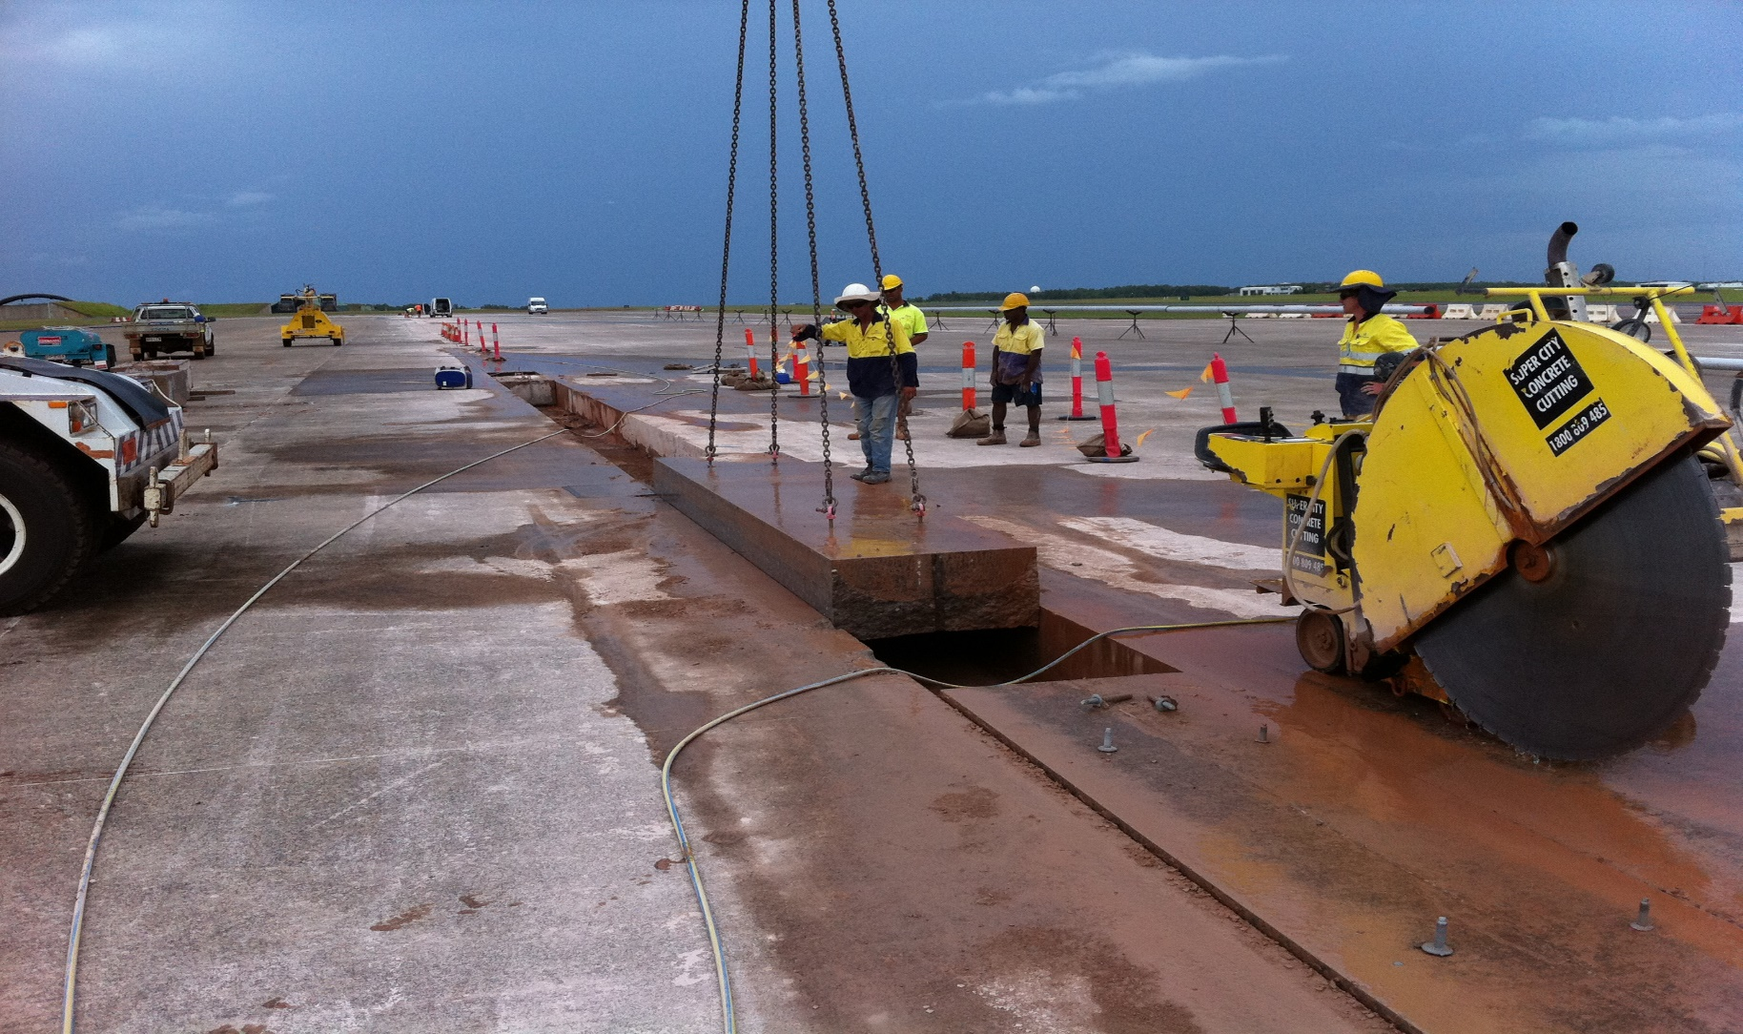

RAAF Base

RAAF Base,Darwin

Service Focus
Three Weeks to Take Off:

Jason Franken from Super City Concrete Cutting discusses the need for innovation while preparing a tender bid.

Removing 4m long concrete blocks 500mm thick after they have been split with C9 Darda splitting cylinders.

Willingness to think beyond prescribed tender documents positioned Super City Concrete Cutting in pole position to win a major tender at the Darwin RAAF Base in 2012.

While the company was well positioned to win the tender based on their relevant experience, specialised equipment and ability to deliver difficult projects within tightly specified timeframes - the deciding factor that won the tender for them was their ability to show flexibility and innovation.

Jason Franken and Alan Torrance from Super City Concrete Cutting demonstrated to the client the savings that resourceful application of specialised equipment could achieve - namely, halving the estimated time required to complete the job.
The Project:
The head project, assigned to Macmahon contractors at Darwin RAAF Base, involved removing an old fuel line and replacing it with a new one. The line lay beneath a 600mm deep concrete apron used by air force fighter bombers during refuelling stops.Minnich A-2C rock drill in action on the way to completing 3,800 no holes 45mm dia x 250mm deep for dowell bar installation.
"The existing fuel supply line was originaly installed in 1964 and had come to the end of its servicabilty," said Jason Franken. "As the fuel line needing replacement was under existing concrete aprons of the runway, we had to protect the integrity of existing aprons by sawing and drilling, rather than jackhammering, which would have damaged the remaining curtain aprons."
Tender Documents:
Originally, the tender documents identified a six-week program for Macmahon contractors to complete the upgrade works. Super City differentiated their bid during the tender process by contracting to do their specified work package in three weeks, utilising proven methods and systems of work.
This provided Macmahons with a program they could work with to ensure that they could remove and install the new fuel line within the six-week schedule. This effectively assisted in reducing downtime for aircraft and saving time, rezsources and budget.
"We were selected because of our previous experience with airport projects and the large horsepower floor saws we use," said Jason. "But what really won us the job was demonstrating our ability to deversify in terms of meeting project deadlines and introducing systems of work that showed we could meet those deadlines."
"Originally, the tender documents specified anchor bar/dowell bar holes to be diamond core drilled, but due to the original program requirement of completing work within six weeks, the time required to complete this task would not have been achievable. We realised this during the tender stage and recommended the Minnich Drill System as an alternative. Production rates with this system are ten times those of conventional core drilling for this application."
Sawing and drilling was a proven method to use on this project, as Super City could draw from experience with similar projects to demonstrate that this system was more economical and faster
Than conventional hammering techniques.
The Project
Excavations involved:
- Five sawing units to cut an access trench 900mm wide by 740m in length across two areas of the refuelling aprons
- Hydraulic bursting systems to break the concrete trench at 5m lengths to assist with the removal and extraction of the sections.
- Once excavations were complete, the company supplied:
- A Minnich Dowel Drill Machine and operator to air drill 4000 no x 45mm diameter holes to a depth of 250mm for dowell bar installation and tie-in of replacement concrete to the excavated concrete apron.

RAAF Base

“We faced many technical difficulties while executing this work and Jason demonstrated his resolve, experience and ingenuity in helping to overcome these challenges as they arose. I would be pleased to use Super City Concrete Cutting again where major concrete removal work is required.”
B. Kerrison, Project Manager, The Engineering Company

Managing Time and Variables:

Commitment to undertake and complete the work in three weeks, was a brave move - but one worth taking says Jason Franken. This was achieved by a dedicated work force that is trained and proficient in the use of the specialised sawing and drilling systems unique to the construction industry.

"It's always difficult to place a definitive time line on projects such as this," said Jason.

"Time allowances are generally based on previous works that are similar in nature, and you work out procedures to maintaintain a certain type of program. So for this job we provided a program duration of three weeks to complete the sawing, bursting and anchor bar drilling for the project. We knew it was a bold move, but we knew we could do it."

While contractors plan for variables, there are always ‘unknowns' and in this instance Super City had a few major ones to overcome

"You expect many jobs to be similar, but two jobs are never the same, and it only takes a couple of unforseen events to take you by surprise and slow the whole thing down," said Jason.

On this occasion one of the ‘unknowns' was the hardness of the concrete (80mpa) that slowed production. Super City overcame this issue by discussing options with operators and suppliers to maximise output of the equipment and diamond blades on hand.
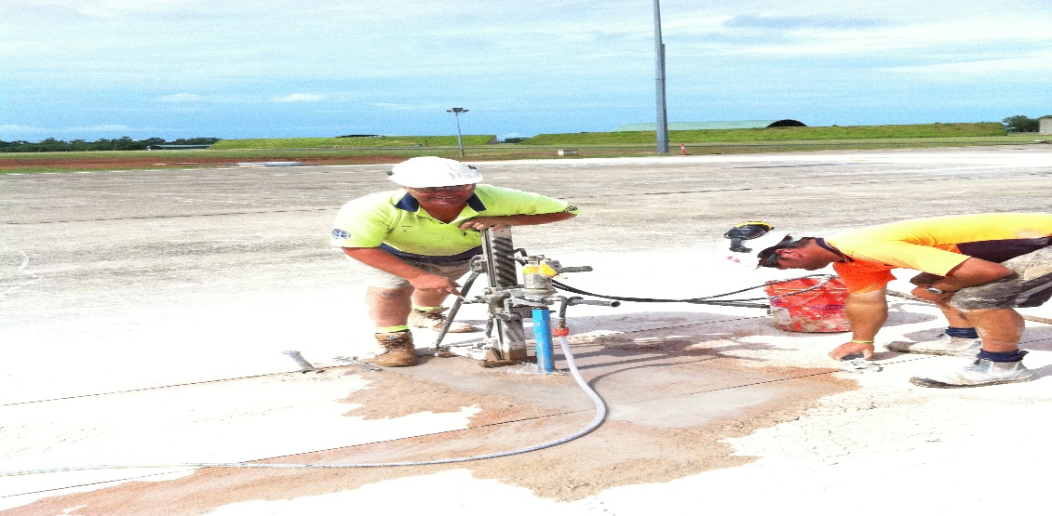
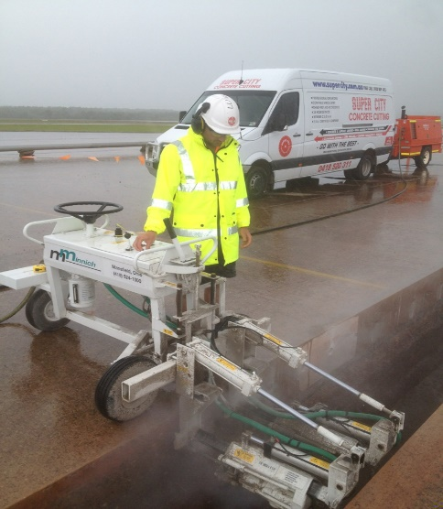

The result was a combined cut measuring 1.4km at an average depth of 500mm, the drilling of 3,800 holes (45mm diameter x 250mm deep) and the removal by MacMahon contractors of 865,000kgs of concrete during the project.
Weather also played a factor, with the team losing two days due to inclement weather - a traditional risk on any outdoor project for contractors.
Eliminating Risk:
One of the major safety concerns on any airport project is a condition known in the industry as Foreign Object Debris (FOD). This is a major concern to air force and civil aviation airlines as any type of material or rubbish entering a jet engine during take-off or landing may contribute to the cause of engine failure.
If an incident does occur and the cause can be attributed to a contractor or sub-contractor, those involved can be liable for repairs to the aircraft.
Part of Super City's SWMS documentation identified this high risk, resulting in the company developing a system to eliminate the risk.
Results:
With both client and Macmahon contractors
delighted with the successful outcome of Hydraulic core drilling 48mm access hole into concrete sections for Darda splitting system.the project, Super City's reputation as a contractor of merit continues to grow as the company's portfolio of concrete drilling, sawing and cutting within large infastructure, commercial, aviation and roadwork projects builds.
Innovation combined with experience, resources to manage the project and systems to minimise risk were the elements of a winning project for the Super City Concrete Cutting team.
Job Statistics:
1. Floors saws: Combined cut measured 1.4 km at an average depth of 500mm in a total of 11 days @ 80mpa
2. Minnich air drill: Drilled 3,800 holes by 45mm diameter x 250mm deep in 63 man hours (or 8 days)
3. 865,000 kgs of concrete trench was removed from the site over the course of the project by Macmahon contractors.
Equipment Used:
Floor saws: Meco 76hp rider saw, Meco 60hp floor saw, Magnum 60hp floor saw, Core Cut 44hp floor saw, Meco 44hp floor saw
Core Drills: Xcalibur hydrauilic XP fitted with high speed 48mm tyrolit core bits
Minnich drill: A-2c fitted with twin 90-pound air motors powered by 275cfm compressor.

