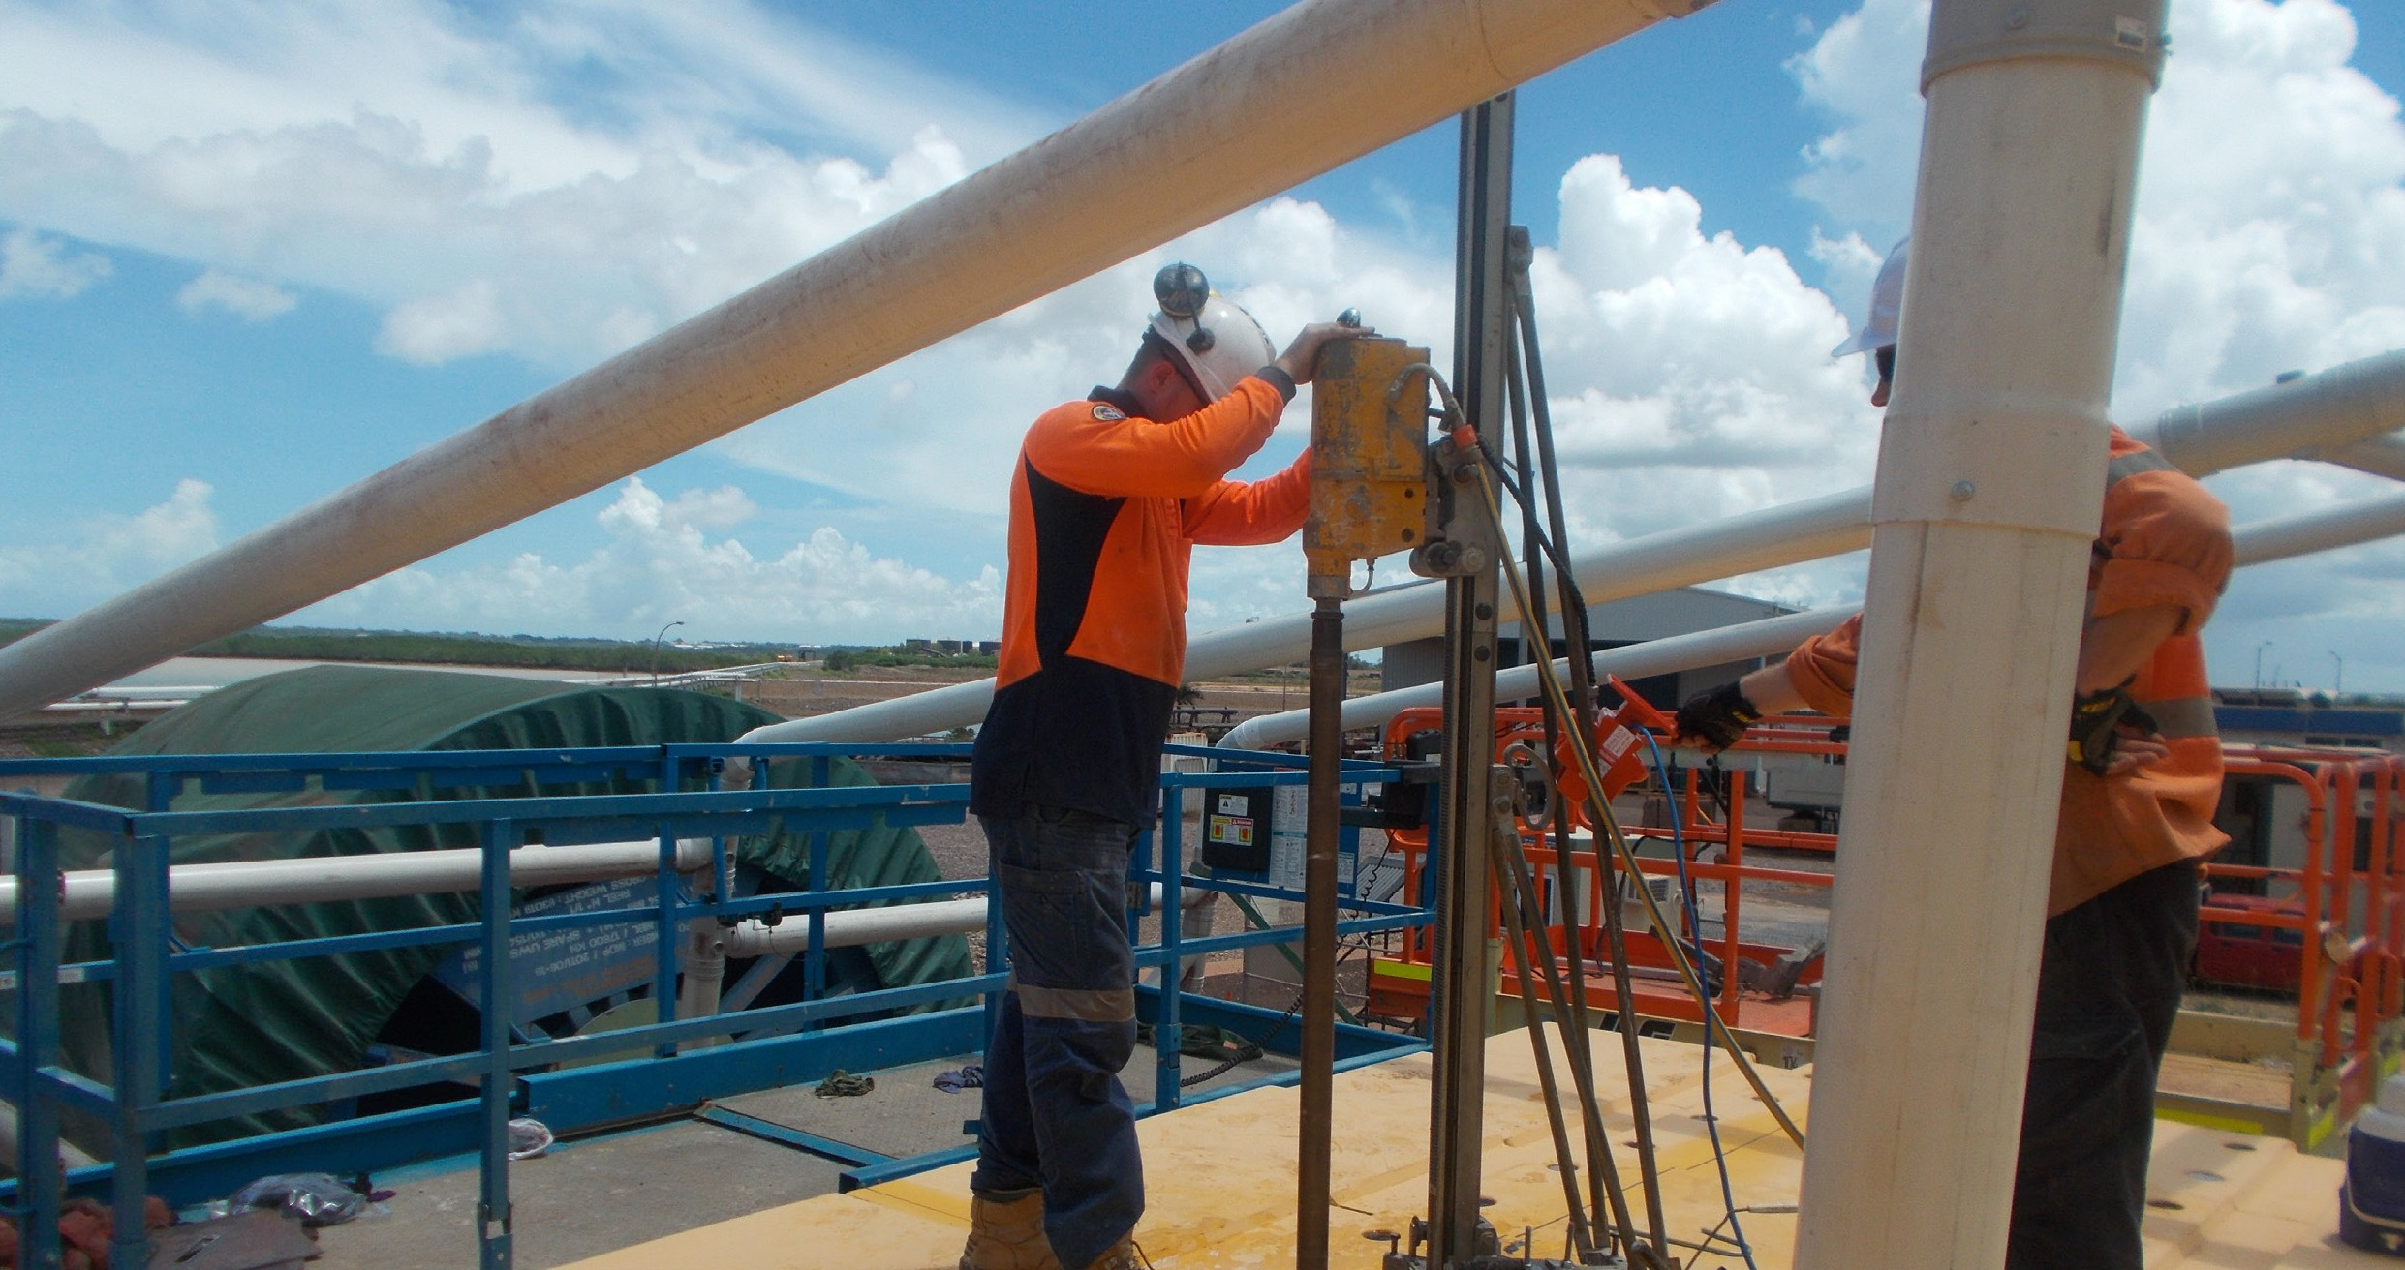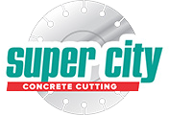Mandorah Jetty

Mandorah Jetty, Dorwin NT

Service Focus

Tight Work Upgrading Mandoroh Jetty in Darwin
Client: Port of Darwin
Contractor: Wolpers Grahl / DEC Projects

Project Manager: Alan Eckert Contract Type Cathodic protection to underside of existing Mandorah Jetty Project Date: Sep 2011

Purpose:
The structural integrity of the concrete jetty has been monitored over a number of years with vulnerable areas being fitted with Cathodic Protection to enhance the asset’s serve life.A recent survey of the jetty indicated further Cathodic Protection was required to ensure
the structural integrity of the jetty.Super City was subcontracted to cut a slot 10mm wide and 50mm deep to the underside of the jetty surface.

What is Cathodic Protection:
Cathodic Protection (CP) is a technique used to control the corrosion of a metal surface by making it the cathode of an electrochemical cell.
The simplest method to apply CP is by con- necting the metal to be protected with another more easily corroded “sacrificial metal” to act as the anode of the electrochemical cell.An- other method of protection impresses a small direct current on a structure Cathodic Protec- tion Systems are used to protect a wide range of metallic structures in various environments.

Common applications are:
- steel water or fuel pipelines storage tanks
- steel pier piles
- ships and boats
- offshore oil platforms and onshore oil well casings
- and metal reinforcement bars in concrete buildings and structures.

Best results indicated that the overage underside cover was around 60mm from the existing reinforcing layers
Procedure:
Super City Concrete Cutting supplied a WX15 track saw and a custom built blade manu- factured by Tyrolit Australia to complete the works.
- A series of 10mm wide x 50mm deep slots were cut using the track saw system to provide access for the cathodic protection.
- 280 lineal meters of inverted sawing 10mm wide x 50mm deep was completed on the jetty so the cathodic protection could be installed.
- The start of the jetty structure from waters edge proved most challenging as the ac- cess area to the underside of the jetty was only 650mm high.

- Operators worked their way through setting up the track in very tight areas, suc- cessfully aligning the track so all specified tolerances were achieved.

Safety:
Due to the restricted work area safety blade guards that are normally fitted to the unit could not be fitted This safety issue was identified prior to work commencing and a safe work method statement was complied and present- ed to the client for approval.The ability to re- mote control the track saw from a safe working distance reinforced our capabilities to maintain a safe work environment for this section of the work.

Project Completion:
The inverted sawing took 4 days to complete, providing the client with sufficient time to install the cathodic protection and grout in the electrical knes. Wolpers Grahl had not before seen a track saw used in this type of application and was very pleased with its versatility and production rates.
Stage 2 of this project will take place in the near future and we are looking forward to working together on the next phase of the upgrade.

Mandorah Jetty

“We faced many technical difficulties while executing this work and Jason demonstrated his resolve, experience and ingenuity in helping to overcome these challenges as they arose. I would be pleased to use Super City Concrete Cutting again where major concrete removal work is required.”
B. Kerrison, Project Manager, The Engineering Company

Stage 2:
Stage 2 of this project will take place in near future and we are looking forward to working together on the next phase of the upgrade.

What is Cathodic Protection:
Cathodic Protection (CP) is a technique used to control the corrosion of a metal surface by making it the cathode of an electrochemical cell.
The simplest method to apply CP is by con- necting the metal to be protected with another more easily corroded “sacrificial metal” to act as the anode of the electrochemical cell.An- other method of protection impresses a small direct current on a structure Cathodic Protec- tion Systems are used to protect a wide range of metallic structures in various environments..

Procedure:
Super City Concrete Cutting supplied a WX15 track saw and a custom built blade manu- factured by Tyrolit Australia to complete the works.
- A series of 10mm wide x 50mm deep slots were cut using the track saw system to provide access for the cathodic protection.
- 280 lineal meters of inverted sawing 10mm wide x 50mm deep was completed on the jetty so the cathodic protection could be installed.
- The start of the jetty structure from waters edge proved most challenging as the ac- cess area to the underside of the jetty was only 650mm high.
- Operators worked their way through setting up the track in very tight areas, suc- cessfully aligning the track so all specified tolerances were achieved.

Safety:
Due to the restricted work area safety blade guards that are normally fitted to the unit could

not be fitted This safety issue was identified prior to work commencing and a safe work method statement was complied and present- ed to the client for approval.The ability to re- mote control the track saw from a safe working distance reinforced our capabilities to maintain a safe work environment for this section of the work.

Project Completion:
The inverted sawing took 4 days to complete, providing the client with sufficient time to install the cathodic protection and grout in the electrical knes. Wolpers Grahl had not before seen a track saw used in this type of application and was very pleased with its versatility and production rates.
Stage 2 of this project will take place in the near future and we are looking forward to working together on the next phase of the upgrade.



