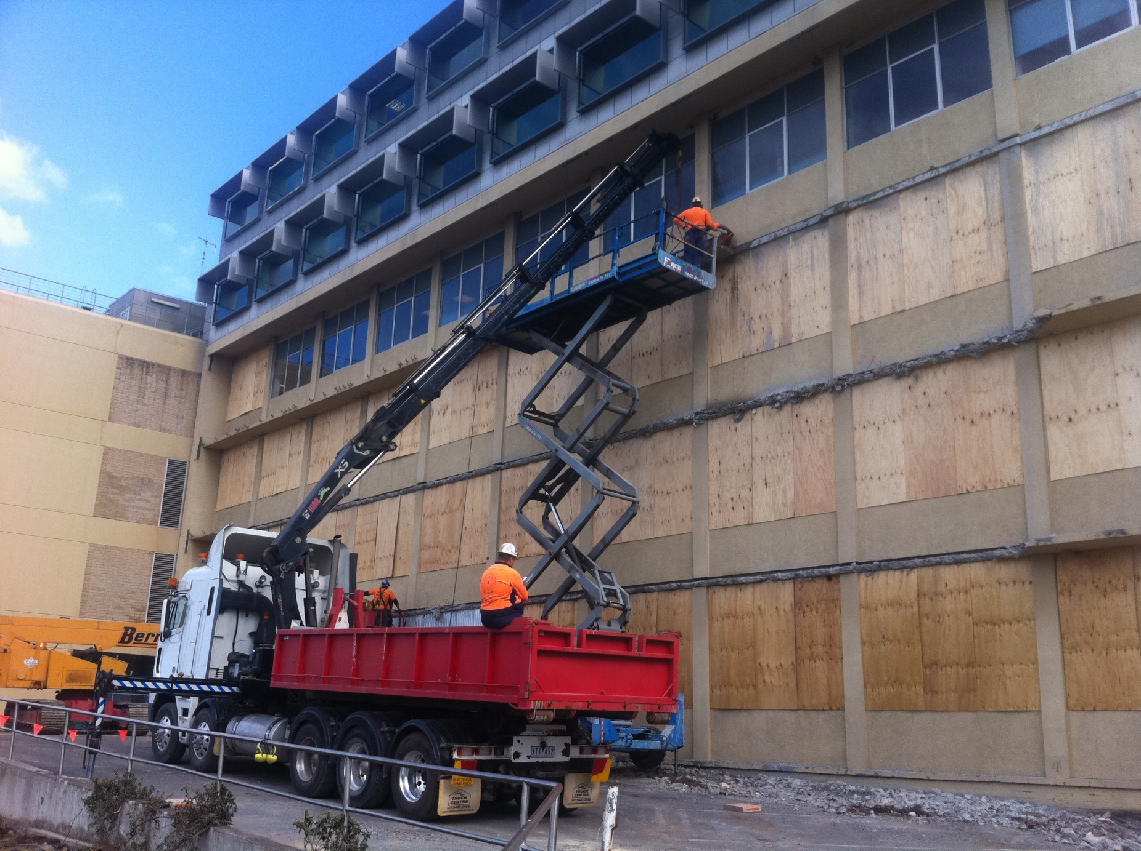

St John of God Hospital

St John of God Hospital, Geelong



Contractor: Kane Constructions

Contract Type: Controlled demolition using diamond wire saw, track saw, floor saw to remove 4 levels of building landings, façade and staircases for new extension works. St John of God Hospital, Geelong, Victoria

Silent Demolition:
When vibration and noise impact sensitive environments, more subtle and controlled demolition approaches are needed. In this ‘life saving' project, Jason Franken from Super City Concrete Cutting found a way to meet the challenge.
Imagine the scene: a hospital ward, sensitive monitors, hushed sounds, soft lights, calm and confident nursing care, patients recovering from operating procedures - and then the jackhammering begins BRRRRRRRRR ... GRRRRRRR ... and on it goes for days on end, penetrating both patients and staff nervous systems like a dental drill.
Jack hammering and hospitals are not a natural fit.
This was the challenge that Jason and his team needed to solve.
The brief, while documented with a little more technicality than written here was to assist in a demolition that upheld the highest safety standards while completing the job with sensitivity, quietness and most importantly - gentleness.Set out work area and core drill access holes thorugh slab sections for list chains.
In other words, no vibration, no noise and no interruption to the important work of the hospital or to its patients..

Controlled Demolition:
In preparing for new extension works at the St John of God Hospital in Geelong, four levels of building landings, façade and staircases needed to be demolished and removed.
1st lift Level 4, 12000kg concrete section cut with diamond wire saw and floor sawWhile usually straight-forward work involving traditional jackhammering and breaking methods, the excessive vibration and noise would have severely impacted four adjacent levels of operating theatres and patient recovery wards. The demolition required a more controlled approach to the work.
Compounding the project's risk and complexity were additional height factors and the irregular shape, size and excessive weight of sections needing removal.
This provided an opportunity for the Super City team to work collaboratively with the existing demolisher (Bernie Leen & Sons) to help solve these challenging issues using specialised equipment and procedures.

Working Safely on the Edge:
One of our principle concerns involved safety," said Jason Franken. "After developing a methodology plan and system of work that met the necessary constraints of the project, we briefed our team on the steps and work sequence to be followed."

"High risk work activities presented challenges around maintaining a safe work environment at all times, so we applied measures to ensure the systems and safety regulations weren't compromised."2nd lift Level 4, diamond wire saw edge beams
As part of this approach, the demolition contractor installed perimeter handrails on the live edge of each work zone. Fitted in a modular format, the railing could be cut and separated, leaving the handrail in place so it was lifted down with the section of concrete being removed.
Operators were fitted with a fall-arrest system prior to sawing and drilling works occurring so that operators, who were wearing body harnesses, could attach themselves to a certified anchor point, further ensuring their safety while working at heights.
Once a live edge had been created another section of handrail was installed and the process repeated throughout the floor levels.
Balancing Safely
As required, safety strategies were built into all work procedures. Another successful strategy gave the crane driver and dog man a safety buffer by having a free edge to lift and move the concrete blocks into. This provided access to measure the weight of the section and monitor how evenly it would lift once the load was separated from the remaining building.
Each concrete section's irregular shape and size made calculating the centre of balance for each lift challenging, but crucial, so that all concrete sections being lifted remained within the radius and lift capacity of the 100 tonne crane deployed for the job. Based on the risk assessment and Safe Work Load (SWL) of the crane, a maximum lift capacity of 16 tonne for any one section was estimated.

St John of God Hospital

“We faced many technical difficulties while executing this work and Jason demonstrated his resolve, experience and ingenuity in helping to overcome these challenges as they arose. I would be pleased to use Super City Concrete Cutting again where major concrete removal work is required.”
B. Kerrison, Project Manager, The Engineering Company

Stabilising the concrete sections once they were free, so they did not shift or roll, minimised the potential failure of the crane's base supports, and possibly the crane itself, as it was working close to its lift limits.
Saving Time and Money
"Separating the concrete sections into large blocks provided considerable benefits to the construction program and budget," says Jason. "By using specialist sawing and drilling systems we completed this part of the demolition project in only 8 days."

"The controlled demolition procedure also allowed the hospital to operate as normal with minimal disruption. These systems are entirely vibration free with far less noise than conventional demolition methods," he said.Level 4 lift 14000kgs

Fortunately, Super City Concrete Cutting's approach attracted attention as Jason describes, "The success and productivity of the sawing and drilling systems led to additional work on the hospital project," proving that silence can speak louder than words.

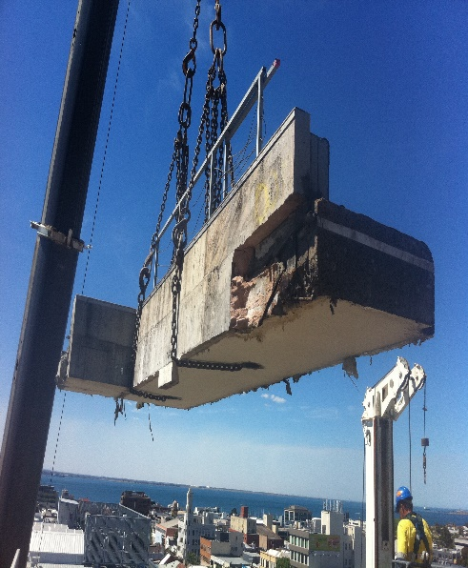
Rarely is a job straightforward. Managing risks and time constraints are usual, but when the impact on a community can be great, and it requires a high level of skill and flexibility to solve problems, few have the insight to see the solution and create not only a procedure that gets the job done, but also ensures the safety of all.

Level 3, corner of building, including stairwell and landing area, 15000kg liftJason agrees. "Hospital environments create a number of challenging considerations that we had to consider when pricing and planning the various stages of work."

"The advantage of specialised sawing and drilling equipment helps us compete more efficiently and competitively, which is very important with the strict parameters hospitals have in place. For them, patient comfort during any construction upgrade is a priority."

Removal Sequence

Level 1 & Ground:
Isolation perimeter cuts were made using diamond wire saw, track saw and floor saws. Bernie Leen & Sons then used a 40 tonne excavator fitted with a hydraulic concrete cruncher to pulverise the remaining areas to ground level.

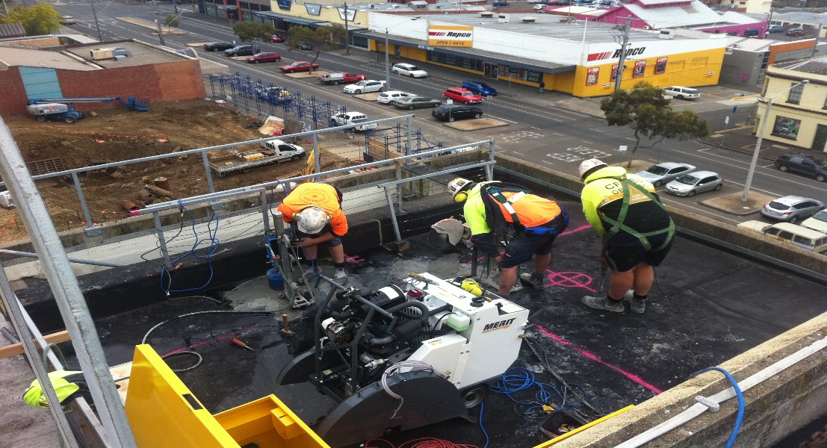

Level 2 & 3: Support columns, internal & external stair panel walls:
Support columns were cut using diamond wire saws with 1no lift hole core drilled through the beam's centre for support. Internal staircases and wall panels were cut using an electric track saw with 2no 175mm core holes in each section for rigging access.Setting up for vertical cut with 1600mm diameter blade
Level 2, 3 & 4: Roof & stair landing
The concrete roof was separated into three lifts with an average lift of 14 tonne. The perimeter roof support beams were diamond wire sawn in four separate locations.
The roof slab was cut using a conventional pavement floor saw to a depth of 400mm. 2no x 175mm core holes were drilled into each section for rigging access of crane chains.
Equipment Used
- Tyrolit SK-B diamond wire saw
- Tyrolit WSE 1217 electric track saw
- Merit 44hp floor saw
- Hilti DD350 core drills
- Tyrolit DME 37 core drills
- Tyrolit BSG 3 diamond wire
- Husqvarna hand & ring saws
- 65kva 3-phase generator
- 100 tonne crane (Williamstown Cranes)
- 40 tonne Excavator (Bernie Leen & Sons)
- Freightliner Crane Truck (Super City)

