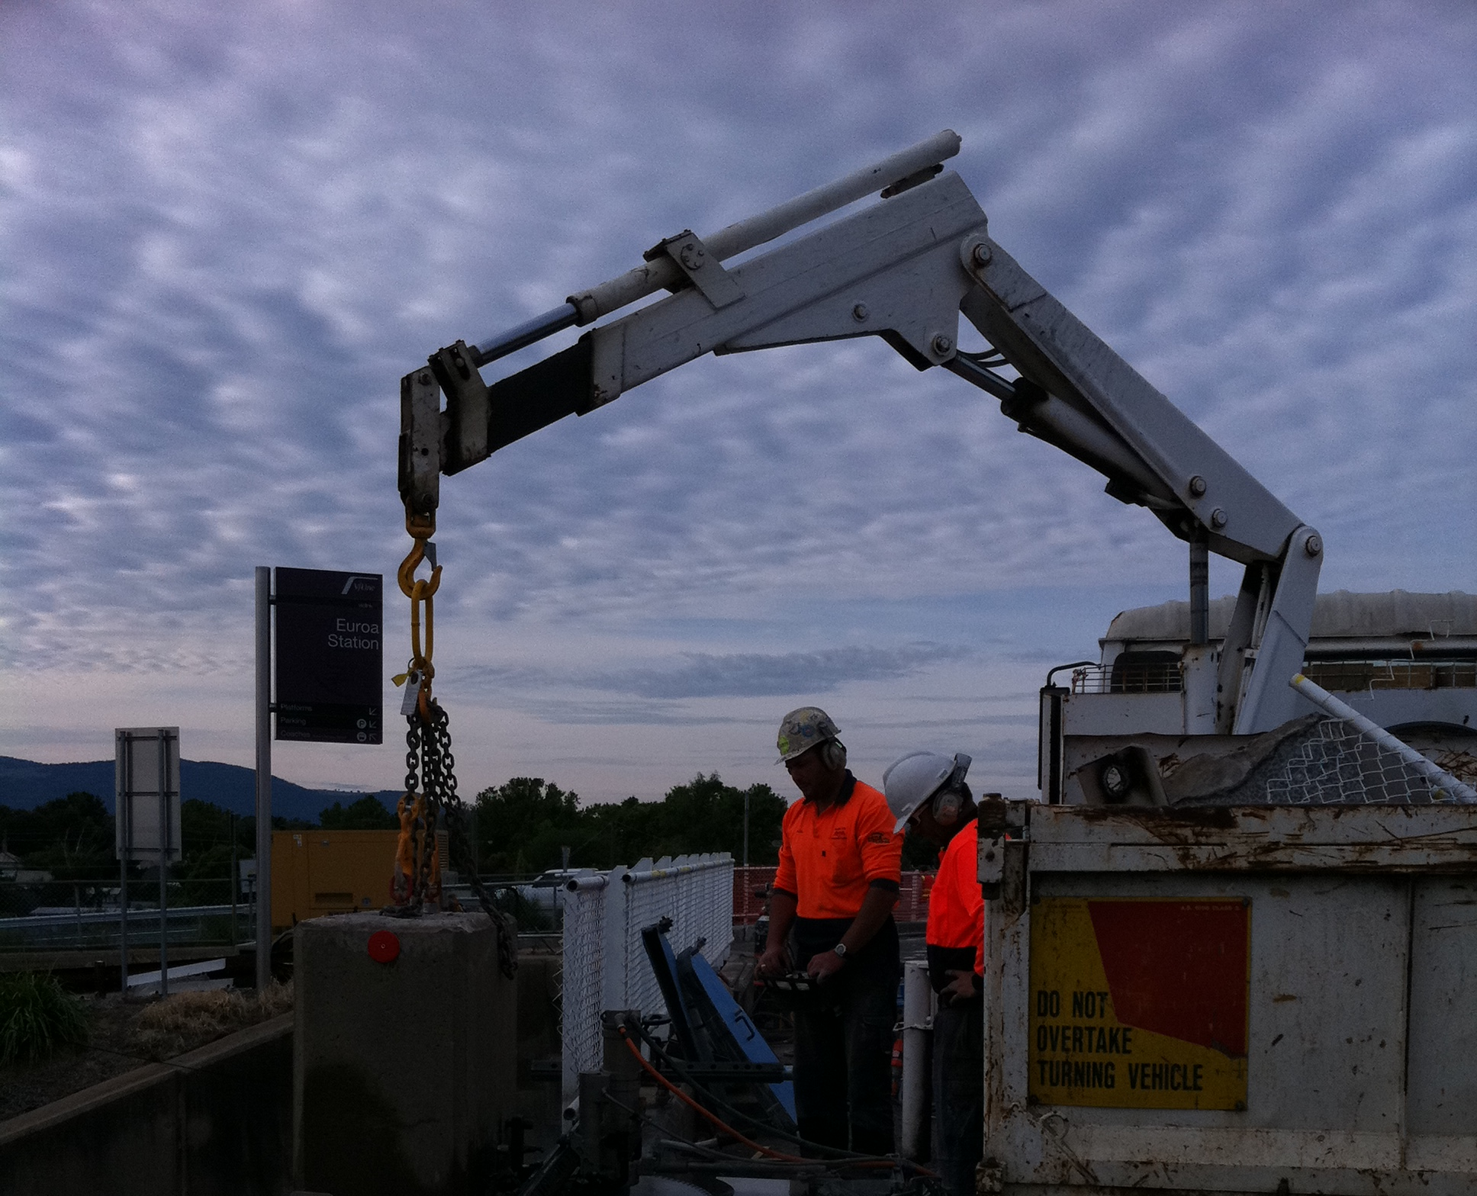
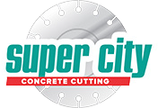
Euroa Bridge

Euroa Bridge, Victoria



Service Focus
Bridge upgrade works with restricted access.

Client: Vic Roads
Contractor: DC Projects

Project Manager: Mark McCarthy

Services Utilised: Concrete Removal, Track Sawing, Wire Sawing, Core Drilling

Location: Euroa, Victoria

Project Date: 2011

The Project:
Saw-cutting 31 opening pockets 400mm (H) x 450mm (L) x 320mm (W) into the existing bridge beam kerbing. Super City used a WX15 track saw to make two vertical cuts 320mm apart followed by one horizontal cut 450mm long to form each opening.
The schedule provided for 12 working days and was completed in 9. Throughout the upgrade works, several agency inspectors visited the site to ensure safety and work procedures were being followed.

- Having risks assessments, safe work
method statements and traffic management plans in place prior to commencement of works ensured the job ran smoothly to finish ahead of schedule.

Maintaining the Bridge’s Structural Integrity:
Installing points for a new railing on the bridge involved using concrete sawing and drilling equipment to cut through existing sections of the rail bridge. The more traditional approach of percussion hammering would have caused structural damage to other areas of the bridge.

Safety Plan: Traffic Control:
The Euroa rail bridge with its narrow two-lane approach required a well-designed traffic control plan. The restrictive environment required us to complete sawing and drilling works on one side of the bridge at a time. To protect operators and equipment from traffic incidents, we erected barricades and closed one lane on the bridge.

Safety Plan: Managing Access Restrictions:
Due to access restrictions on the bridge deck, the horizontal cut for each opening had Euroa Bridge to be made from the external side of the bridge beams. This presented a few challenges that we worked through with the client during the tender stages. As the rail lines beneath the bridge were very active, we established safety measures and procedures to minimise the potential of train strikes during operations. A vehicle access platform was hired by DC projects to provide access for Super City operators and equipment to suspend them over the train lines and complete their sawing tasks. Two train signal men were positioned 1km down the lines to

provide advance warning when a train was
approaching. Once radio contact was received the works were suspended with operators and equipment removed from the suspended platforms.

Concrete Removal:
Several sections of bridge kerbing were 1200mm wide and required removal to be flush against the existing bridge deck. Super City supplied a WX15 electric diamond wire saw to complete these cuts, enabling the sections to be removed. As part of the subcontract included removal of the concrete sections, Super City provided one of their crane trucks to support and remove the various concrete blocks on completion of the sawing works.

Drilling Access Holes:
The final part of the contract required access holes for the new bridge posts to be drilled through the bridge deck. Super City supplied three DK32 core drills to core 200 holes x 28mm diameter through the 150mm thick bridge deck.

